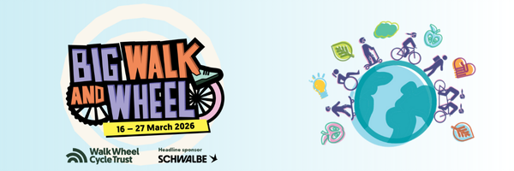

Dear Parents/Carers,
We have some exciting news for you! We are taking part in Big Walk and Wheel, the UK’s largest inter-school cycling, walking, wheeling and scooting challenge. The challenge runs from 16 – 27 March 2026. It’s free to take part and we would love everyone to be involved.

What do you need to do?

Encourage your child(ren) to walk, use a wheelchair, scoot or cycle to school on as many days as possible during the event.

Including everyone
We want to make sure that everyone can get involved in Big Walk and Wheel.
We know it may be more difficult for some pupils to take part than others. If you want to discuss more about your child(ren)’s specific needs, please contact Harshila Parmar and we will make sure to look into how your child(ren) can take part.

Why we are taking part
Big Walk and Wheel is a great way to build physical activity in children’s daily routine which is important for their physical health and mental wellbeing.

Active school runs also help to reduce congestion and air pollution outside the school gate. A 2021 YouGov study showed nearly half of UK children worry about air pollution near their school. And that children thought active travel was the best away to bring down these pollution levels.
Plus, there are some great prizes to be won every day if we get enough children taking part!
Useful resources
To help you prepare, Walk Wheel Cycle Trust has developed a handy Parent/ Caregiver page on the challenge website. It is packed with advice to help you have a hassle-free journey to school.
For more information about the event go to www.bigwalkandwheel.org.uk.
Enjoy the challenge!

Best wishes

Harshila Parmar
Deputy Headteacher

